

FACULTY OF SCIENCE & TECHNOLOGY

BSc (Hons) Computer Networks
May 2024

Simulating Virus Spread and Mitigation Strategies in Temporal Networks

by

Shahir Ali

Faculty of Science & Technology
Department of Computing and Informatics
Final Year Project

Abstract

Despite the pandemic, this country has been showing a downhill trend in general self-isolation, with people becoming more and more likely to go to work even when they’re unwell (CIPD, 2021). Perhaps the first bastion against the spreading of illness should be our own behaviour and workplace policies, through basic NPIs (non-pharmaceutical interventions).

This paper explores the effects of NPIs by way of simulations performed on real time-respecting contact datasets, as well as the effects of temporal structures and network topology on viral spreading and their relevance to the design and selection of viral interventions.

The paper found that in the context of COVID-19, self-isolation upon experiencing symptoms alone is ineffective and on its own only gives a 13.6% improvement over doing nothing, assuming a 5 day asymptomatic incubation period (Zaki & Mohamed, 2021).Hybrid scheduling without any self-isolation proved to be extremely effective, decreasing total infections by up to 50.9% with just two WFH (work from home) days per week, with extended non-contact periods showing increased effectiveness over shorter, more distributed ones. Maximum effectiveness is achieved when combining the pair of these interventions, with blanket hybrid working acting as a pre-emptive measure by reducing contacts generally, and targeted self-isolation catching any stragglers with minimal extra lost contacts and achieving an additional 20-30% decrease in peak infection level.

These findings could be used to guide workplace policy on ways to minimise the human and actual cost of illness.

Dissertation Declaration

I agree that, should the University wish to retain it for reference purposes, a copy of my dissertation may be held by Bournemouth University normally for a period of 3 academic years. I understand that once the retention period has expired my dissertation will be destroyed.

Confidentiality

I confirm that this dissertation does not contain information of a commercial or confidential nature or include personal information other than that which would normally be in the public domain unless the relevant permissions have been obtained. In particular any information which identifies a particular individual's religious or political beliefs, information relating to their health, ethnicity, criminal history or sex life has been anonymised unless permission has been granted for its publication from the person to whom it relates.

Copyright

The copyright for this dissertation remains with me.

Requests for Information

I agree that this dissertation may be made available as the result of a request for information under the Freedom of Information Act.

Signed: Shahir Ali .

Name: Shahir Ali

Date: 06/05/2025

Programme: Computer Networks

Original Work Declaration

This dissertation and the project that it is based on are my own work, except where stated, in accordance with University regulations.

Signed: Shahir Ali .

Name: Shahir Ali

Date: 06/05/2025

Acknowledgments

Thanks to Wei Koong Chai for supervising this project and for his guidance in its creation.

Table of Contents
1 INTRODUCTION 1
1.1 Problem definition 1
1.2 Aims and objectives 1
1.2.1 Aims 1
1.2.2 Objectives 1
1.3 Risk Analysis 3
2 Literature Review 5
2.1 Overview of Past Work 5
2.2 SIR Model 6
2.3 Selection of Disease Parameters 6
2.4 Network Science 7
2.4.1 Temporal Betweenness Centrality 7
2.4.2 Temporal Closeness Centrality 8
2.4.3 Clustering Co-efficient 8
2.4.4 Transitivity 8
2.4.5 Degree 8
2.4.6 Diameter and Radius 8
2.4.7 Degree Assortativity 9
2.5 Justification Of My Project 9
3 Planning and Methodology 10
3.1 Project Methodology 10
3.2 Gantt Chart 10
3.3 Data Sources 10
3.4 Tools and Techniques 10
4 Design and Implementation 12
4.1 Structure and Framework 12
4.2 Setup 14
4.3 Exploratory Data Analysis 15
4.3.1 Average Contacts per Timestep: 15
4.3.2 Contacts per Timestep Frequency Graph: 16
4.3.3 Blank Timesteps Between 2 Timesteps: 17
4.3.4 Contacts Aggregate Between 2 Timesteps: 17
4.3.5 Network Properties 18
4.4 Simulation – Control Version 20
4.5 Metrics 20
4.5.1 Lowest, Average, Highest Peak Infected 20
4.5.2 Peak Infection Median Absolute Deviation 20
4.5.3 Epidemic Threshold Passing Probability 21
4.5.4 Total Infected 21
4.5.5 Missed Contacts 21
4.6 Self-Isolation After X Days Infected for Y Days 21
4.7 Self-Isolation Until Recovered 22
4.8 Hybrid Working 23
4.9 Self-Isolation Until Recovered and Hybrid Working 23
4.10 Targeted Immunisation 24
4.11 Shuffled Timestamps 24
4.12 Static Network Simulation 24
5 Evaluation of Artefact (Following from Appendix D) 25
5.1 Fulfilment of Aims 25
5.1.1 To understand the dynamics of viral spread in a temporal contact network using time-respecting SIR simulations, and investigate the effect of temporal structures on viral spread 25
5.1.2 To evaluate the effectiveness of different viral spread mitigation strategies. 25
5.2 Fulfilment of Objectives 25
6 Conclusion and Reflection 27
6.1 Improvements 27
6.2 Limitations 27
6.3 Future Work 27
7 References 28
APPENDIX A – Basic Simulation Code 30
APPENDIX C – Static Network Simulation Code 33
8 APPENDIX D – Analysis of SImulation Results (Artifact) 36
8.1 Control 36
8.2 Self Isolation After X Days Infected for Y Days 37
8.3 Self-Isolation Until Recovered 39
8.4 Hybrid Working 40
8.5 Self-Isolation and Hybrid Working 43
8.6 Evaluation of NPIs (Non Pharmaceutical Interventions) 44
8.7 Targeted Immunisation 44
8.8 Investigations of Temporal/Topological Structure 45

LIST OF FIGURES
Figure 1: The SMART Framework (BiteSize Learning, 2023) 2
Figure 2: Risk Score Matrix 3
Figure 3: SIR Formulae (Continuous) 6
Figure 4: SIR Formulae (Discrete) 6
Figure 5: Betweenness Centrality Formula 7
Figure 6: Temporal Closeness Formula 8
Figure 7: Clustering Coefficient Formula 8
Figure 8: Transitivity Formula 8
Figure 9: Project Schedule Gantt Chart 10
Figure 10: Simulator Basic Structure Flow Chart 13
Figure 11: Dataset File Screenshot 14
Figure 12: Contacts for each timestep (ascending) 16
Figure 13: Betweenness centralities for each node 18
Figure 14: Closeness centralities for each node 19
Figure 15: Sample figure. 21
Figure 16: Sample figure. 25

INTRODUCTION

Problem definition
In a 2021 survey by CIPD, 86% of UK workers said that they had observed people coming into work ill at their organization in the last 12 months, compared to 72% in 2016 and just 26% in 2010 (CIPD, 2021). Furthermore, the UK’s Health and Safety Executive stated that 123,000 workers diagnosed with COVID-19 in 2021/22 believed they were exposed to the virus at work(HSE, circa 2022). This work culture of feeling pressured to come in when having an infectious illness, like the cold, flu or even COVID-19, presents a serious public health concern, and has the potential to start an “office epidemic”, resulting in significant loss of productivity, and of course, unneeded suffering.

The aim of this project is to investigate viral spread, with COVID-19 as the primary basis given the body of research on it, and measures against it that can be implemented in places such as schools and workplaces using simulations on contact datasets modelled as temporal networks. These preventative measures will be focused on changes in behaviour, such as hybrid working and people staying home when they fall ill, though vaccination may also be touched on.

The purpose of this project is to create findings on the spreading effects of presenteeism when sick and the mitigation effects of hybrid working which could guide policies for workplaces and schools, as well as investigating the effects of temporal networks

Though it may not seem so initially, this project can be considered to lie within the domain of network science, since people and contacts between them can be modelled as a system of nodes and edges, i.e. a network. This means that network theory can be applied to this project.

Aims and objectives

Aims

- To understand the dynamics of viral spread in a temporal contact network using time-respecting SIR simulations, and investigate the effect of temporal structures on viral spread
- To evaluate the effectiveness of different viral spread mitigation strategies.

Objectives
The project objectives will be written using the SMART targets framework to describe them, as shown in the image below.
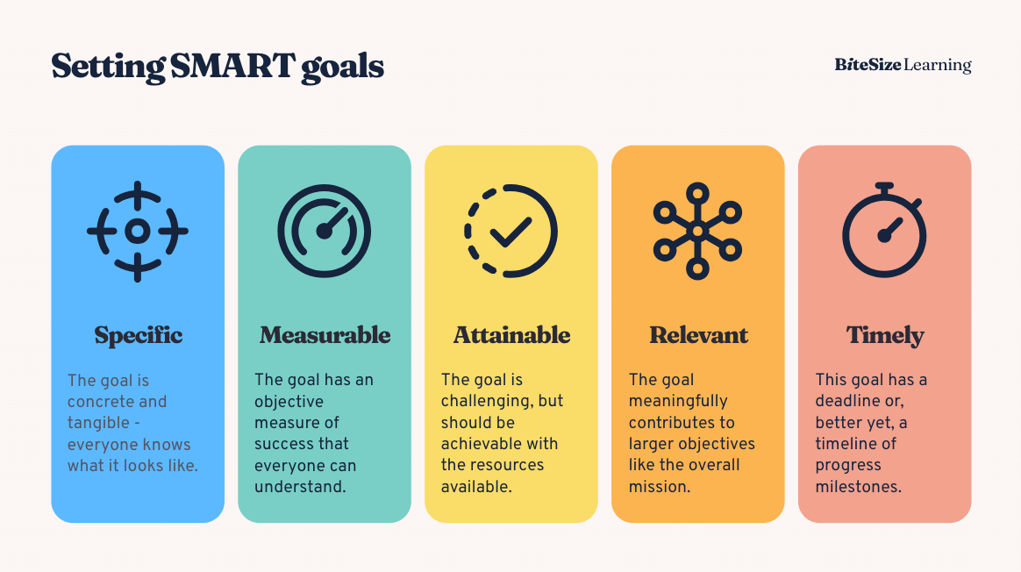
Figure 1: The SMART Framework (BiteSize Learning, 2023)

Objective 1: Understand and analyse viral spread in temporal networks

S | By simulating viral spread in different network structures
M | Using at least 3 different network structures
A | Using existing temporal network data and network techniques
R | In order to inform intervention design and understand the effect of temporal structure on viral spread.
T | Aiming to build on this throughout the project.

Objective 2: Develop and evaluate viral spread mitigation strategies within the simulation

S | By adding them as modifications to my simulation code, their primary function in the code being to conditionally skip contacts.
M | Implementing at least 3 different mitigation strategies
A | Based off existing and feasible to implement strategies.
R | In order to understand their effectiveness and to inform my conclusions on what policies would be best implemented by a school or workplace.
T | Aiming to complete this by the 14th of April.

Objective 3: Provide insights for real world applications

S | Critically evaluate the different mitigation strategies trialled in the simulation and comment on the impact of my findings on how it impacts for real world sickness policies.
M | Using metrics from the simulation trial to justify my conclusions
A | Based off existing and feasible to implement strategies.
R | In order to understand their effectiveness and to inform my conclusions on what policies would be best implemented by a school or workplace.
T | Aiming to complete this by the 5th of May.

Risk Analysis

There are many obstacles that may be faced in a project. To mitigate these obstacles, I am completing a risk assessment table in order to evaluate the threat that each risk poses and the mitigation and contingencies for them. I will also be giving each risk a score based on the combination of the likelihood and the impact, as defined in the following matrix.
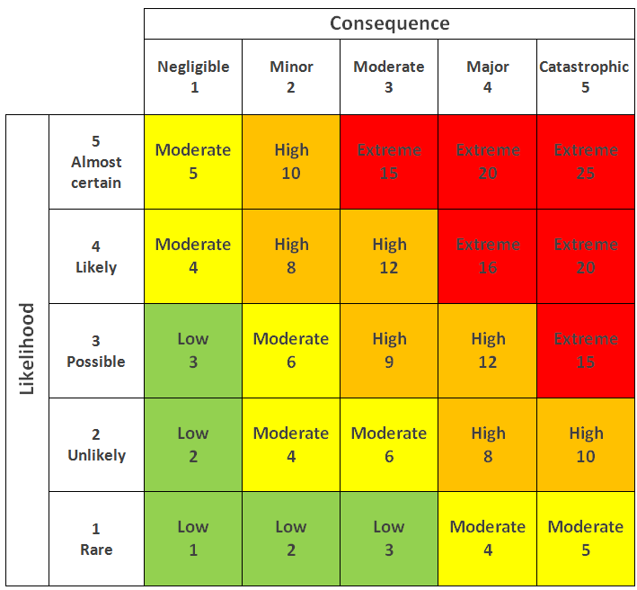
Figure 2: Risk Score Matrix

Risk | Likelihood (1–5) | Impact (1–5) | Risk Score | Mitigation | Contingency
Data quality issues (missing or inconsistent temporal contacts) | 3 | 3 | 9 | Use data validation scripts to detect and handle anomalies. | Use synthetic or alternate datasets if the original is unusable.
Simulation code contains logical errors | 3 | 4 | 12 | Use modular design and test components individually with known data. | Roll back to a previously validated version of the code.
Inaccurate model assumptions (e.g. β or µ not realistic) | 2 | 1.5 | 3 | Cross-check with literature; run sensitivity analysis on parameters. | Clearly document limitations and compare with alternate model variants. In any case, this is not of major impact as the comparison of interventions in a general viral spread scenario (not for a specific virus) is the main object and so long as the values of β or µ are in the right ballpark this should
Computational limitations (e.g. slow simulation, memory errors) | 3 | 3 | 9 | Optimize data structures; limit network size where feasible. | Run on university computers or use Google Colab Pro/local machine.
Version control issues/loss of code | 2 | 5 | 10 | Use Git with frequent commits and cloud backup (e.g. GitHub). | Recover from previous commits, backup, or store on cloud platform; keep exported versions of working simulations.

Literature Review

Overview of Past Work
The modelling of infectious disease spread has long relied on compartmental models such as the Susceptible-Infected-Recovered (SIR) framework (Kermack & McKendrick, 1927). While effective for capturing general trends, traditional SIR models often assume homogeneous mixing, failing to represent the complex and time-varying nature of real-world contact patterns.

To address this, recent work has integrated temporal networks into epidemiological simulations. Unlike static graphs, temporal networks represent contacts as edges that appear and disappear over time, capturing when interactions occur (Holme & Saramäki, 2012). This time-dependence allows for more realistic modelling of transmission dynamics, especially when considering interventions that affect contact timing and frequency (Masuda & Holme, 2017).

Past studies have investigated the effects of temporal structure on viral spreading by destroying the structure of the temporal network in different ways and comparing how the spreading behaviour changes. Such methods include shuffling timesteps between contacts, as well as flattening the temporal network into a static one and giving each node or edge an activation probability proportional to their frequency within the temporal network data (Rocha et al., 2011). This paper concludes that temporal structures accelerate viral spread as well as broadening the outbreak size distribution, but others are of the opinion that temporal structures bottleneck viral spread (Holme & Saramäki, 2012).

There has been past research into the effects of hybrid working on infection reduction, such as Mauras et al. (2021) which compared splitting people into two shifts with traditional on/off hybrid schedules, as well as comparing weekly vs daily schedule changes. The study found that splitting into two shifts (halving the contact pool per person) was better than on/off, and that weekly schedule changes were better than daily. This I suppose was because splitting shifts protects half the people from infection if they never encounter the other shift, and because a single extended period of non-contact gives more opportunity for everybody to recover and destroy the outbreak, than little-and-often non contact. There is also work showing that “hybrid days” where there is a choice between WFH and in-office work had 11-20% lower infection risk than “anchor days” where everybody must attend in-office (Jung et al., 2025)

Temporal centrality metrics such as temporal betweenness have been shown to identify influential nodes in dynamic spreading processes (Pan & Saramäki, 2011). Targeted interventions based on these metrics—such as vaccinating high-centrality nodes—can significantly reduce outbreak size compared to random strategies (Valdano et al., 2015). However, such structural interventions may not always be practical or equitable, particularly in decentralized or privacy-sensitive contexts.
This has led to growing interest in behavioural interventions, such as self-isolation when symptomatic and hybrid working models, which reduce contact rates without requiring knowledge of the underlying network structure. Empirical studies during the COVID-19 pandemic demonstrated the effectiveness of such strategies in reducing transmission, particularly in workplace and school settings (Koo et al., 2020; Ferguson et al., 2020).

SIR Model
The SIR model, as defined by Kermack and McKendrick in 1927, was a seminal work in the advancement of the knowledge of epidemic dynamics. It demarcates each node in the population as either Susceptible, Infected or Recovered, and by a system of differential equations models the spread of the infection from the Susceptible to the Infected, and the transition of the Infected to Recovered. However, this system has a shortfalling in that it assumes homogeneous mixing between the population.

In this project, two adaptations of this framework will be used. One for simulation and one for a discrete time, homogeneous mixing assuming model.

The adaptation to be used in the simulation uses an infection probability, β, and a recovery rate, μ. Instead of assuming homogeneous mixing between the population, the temporal network simulation version of this framework applies infection logic at each contact between S and I and recovery logic at each timestamp. This allows for the SIR framework to now account for the topology of the network. This is a ubiquitous approach within this area, and is used by each one of the studies in the previous section (Holme & Saramäki, 2012; Rocha et al., 2011; Masuda & Holme, 2017; …)

The second adaptation to be used will be a discretised version of the continuous time equations seen below, where S, I and R are the populations of each of those categories at time t, and β and μ are infection and recovery probabilities.

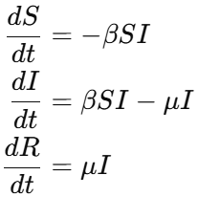
Figure 3: SIR Formulae (Continuous)

Using Euler’s method (Euler, 1768) for approximating differential equations as iterative functions gives:
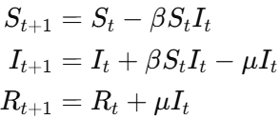
Figure 4: SIR Formulae (Discrete)

This model will be used for the purposes of comparing its results to those of the temporal network simulation, in order to understand the effects of the temporal network’s topology and temporal structure on viral spreading.

Selection of Disease Parameters

Most of the assumptions bear fairly wide margins. Infection probability is modelled as low as 0.01 in some papers with an epidemic still occurring (Stehlé et al., 2011) and even up to 1 to explore theoretical worst case scenarios (Rocha et al., 2011). So long as the infection probability is within reasonable bounds, the resulting R₀ can be checked against those of COVID-19, which in one meta-analysis was estimated at 3.32 at the beginning of the pandemic, but the studies specified in the meta-analysis ranged between 1.90 all the way to 6.49 (Alimohamadi et al., 2020).

Recovery rate per day can be modelled as a reciprocal of infection duration. 97% of people are typically recovered from COVID-19 after 10 days (Walsh et al., 2020). A recovery rate that can replicate this would be 0.000081/20s as if we take the probability of not recovering, which is 0.999919, and raise that to a power equal to the number of twenty second timesteps in 10 days which is 43200, this will give us the probability of a person not recovering in 10 days being 0.030.

The median incubation time of the original COVID-19 has been calculated as 5 days (Zaki & Mohamed, 2021). However, later variants such as Omicron have presented a shorter incubation time at approximately 3 days on average (Tanaka et al., 2022). To make my findings more broadly applicable for different viruses, the incubation time will be varied between 1 and 5 days in the simulation trials.

Network Science
A key factor, and perhaps the primary factor that dictates how a virus spreads through a network is its topology. To further understanding of the topology of the network, various metrics deriving from network theory can be used, which will be explained in this section along with their relevance to viral spreading behaviour.

Temporal Betweenness Centrality
Betweenness centrality measures for a given node, how often that node is in the shortest path between every pair of every other node in the network. A node with high betweenness centrality can be thought of as a hub or gateway within the network, and would have the effect of controlling the flow of the virus by transmitting across different clusters and to isolated nodes.The formula is given in Fig. 5 where v is the node being observed, σ(s,t) is the number of all shortest paths from node s to node t and σ(s,t|v) is the number of these shortest paths that pass through node v.

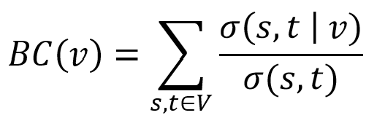
Figure 5: Betweenness Centrality Formula

But the shortest paths must be calculated differently for a temporal network than for a static network for multiple reasons. One is that paths are not copresent, the second is that a maximum waiting time between hops must be delineated, and third is that connections must only travel forwards in time. None of these things can be accounted for by standard algorithms.

The temporal betweenness centrality algorithm used in the Pathpy library, which I will be using, is based on the one devised by Buß et al. (2024) which is designed to consider the above points when finding paths, specifically the one considering the foremost paths.

In temporal networks, there are 3 different types of path that can be called ‘shortest path’. The one requiring the least hops (shortest), the one that has the earliest arrival time (foremost) and the one that has the shortest travel time (fastest). Pathpy uses the algorithm considering the foremost path because early arrival is of more importance within a viral spread simulation, since the earlier a node is infected, the more time it has to cause more infections. Therefore, the same algorithm is used as in Figure 5, but just with different criteria for shortest path.

Temporal Closeness Centrality
Closeness centrality measures for a given node, the sum of the reciprocals of the shortest path length between the node in question and every other node in the network. A node with high closeness centrality can be considered to be “close” to all other nodes and therefore can convey a message to any other node quicker on average. This makes that node topologically central in the network. Within a viral simulation, such a node would cause a rapid central outbreak in a large portion of the network, but not necessarily controlling the flow.

As before, in a temporal network there are additional challenges in finding shortest paths which make standard algorithms infeasible to use. Pathpy uses an approach based on Beauchamp (1965), again considering foremost paths. The following figure shows the formula for temporal closeness, where i is the node being measured, j is the node the distance is being measured between and τ(i, j) is the foremost path between i and j.

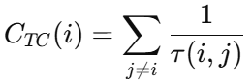
Figure 6: Temporal Closeness Formula

Other Network Metrics
A glossary of other network metrics that will be mentioned in this project can be found listed with formulae and explanations in Appendix F

Justification Of My Project
Despite the breadth of previous work in this area of interest, few studies have systemically compared different styles of contact reduction in temporal network models. Moreover, the specific dynamics of when individuals isolate and for how long, as well as the effect of different weekly schedules of hybrid working on viral spread remains underexplored.

This project builds on these findings by simulating viral spread on a real temporal contact network. It compares the outcomes of different behavioural interventions, such as staying home when infectious and hybrid working, as well as immunisation. By doing so, it aims to clarify the conditions under which simple behavioural changes can be as effective as more resource-intensive structural measures. It will also investigate the effects of temporal structures on viral spread by using various methods of destroying temporal structure and analysing the effects, comparing to the results of past findings.

Planning and Methodology

Project Methodology
My project has defined requirements, a bounded timeframe, a small team (just me) and a familiar domain. However, the scope of my project is variable subject to my findings and what investigations I think may be beneficial to the project. Therefore, my project will follow a Waterfall methodology where each segment of the project is completed in step, as this is best suited to my needs as a small, bounded project with a single developer, since with this being a graded piece of work, it is necessary that each criterion which will be graded gets time allotted to it, and that all of these steps are completed before the due date. However, a modification to the standard waterfall is that I will be revisiting my code ad-hoc throughout the project in order to make small additions after the main artefact coding period of my project.

A shortfall of Waterfall is that development and testing are started quite late, however since the technologies being used (Python, Jupyter, Pandas, .etc) are well known to me, this is not such an issue.

Gantt Chart

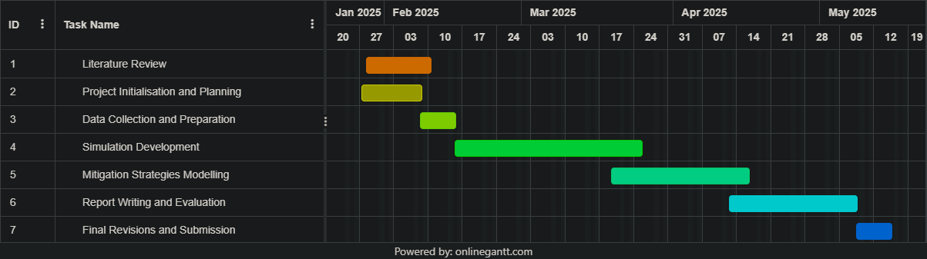
Figure 9: Project Schedule Gantt Chart

Data Sources
The temporal contact dataset I intend to use is the InVS15 (Sociopatterns, 2018) dataset from Sociopatterns, an organization which has been collecting such data and freely releasing much of it for public use since 2008. This data was collected at the Institut de Veille Sanitaire across 2 weeks using wearable RFID badges detecting face-to-face proximity, with a resolution of 20s. There are over 78,000 contacts in the dataset.

Tools and Techniques

Python: The language I will be using for all the programming in this project. It has wide support and a multitude of libraries which will help in my project.

Pandas/NumPy: These are widely used libraries for data storage and manipulation. Pandas offers the powerful DataFrame data structure and integrates with NumPy which can be used to perform various statistical analysis operations.

Pathpy: This library allows me to store my contact dataset in a special temporal network data structure which I can use to calculate network metrics, such as temporal closeness centrality and temporal betweenness centrality. This is needed because the standard network libraries such as Networkx don’t consider that connections can only go forwards in time.

Google Colab: I have chosen Colab as my IDE as this project lends itself well to being done in a Jupyter Notebook, since no user interface is needed and I can organize my code in a modular fashion as a sort of document, differing from a traditional wall of text or jumble of directories. Colab is my choice of Jupyter environment because of its cloud save and cloud execution features, which will keep me from losing any work whilst also saving battery on my laptop which I will be primarily working from.

SIR Model: This is a common viral spread modelling/simulation framework which I will be using in my simulation, established by Kermack and McKendrick in 1927. It marks each person as Susceptible (not yet infected, still able to catch the illness), Infected (can transmit the illness to Susceptible individuals) and Recovered (immune, either by having been infected before or by other means). Each contact between an Infected and Susceptible individual has a chance of β of transmitting the illness and turning the Susceptible into an Infected. Every timestep has an independent chance of μ for each Infected to become Recovered.

Design and Implementation

Structure and Framework

The structure of the temporal network simulation with no interventions is outlined in the flow chart below

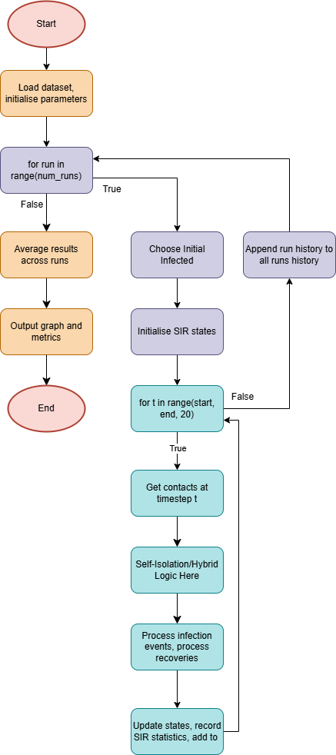
Figure 10: Simulator Basic Structure Flow Chart

After loading the dataset and initialising the parameters (start time, end time, number of runs, infection probability, recovery rate), an enclosing loop is established which dictates the number of times my simulation will be run. Within this loop is the main simulation logic. Initially, the first infected node is selected out of the first 10 nodes in the dataset, which are from the first 5 contacts. The SIR states are initialised as making all Susceptible, then changing the state of the first infected to Infected, then adding any vaccinated to Recovered.

Within the blue inner loop is where the main simulation logic resides. This code loops through the timestamps from beginning to end in steps of 20 seconds (as that is the resolution of my dataset), gets the contacts marked with that timestamp. Here is where any choices are made to skip contacts, either based on the timestamp or nodal properties. If this condition is passed, then if the nodes specified in each contact have one Infected and one Susceptible, then an infection event occurs, wherein the Infected has a probability of infecting the Susceptible according to the parameter of infection probability. This is repeated for each contact in the timestep.

Following this, each Infected node is given a probability of recovering according to the recovery rate. This completes the infection logic, whereafter the state changes are solidified and the counts of S, I and R are added to the log. The peak infection level is also appended to a separate log.

This is repeated for each timestep beginning to end, at which point the history of that run is added to the data structure storing the histories of all runs. A new run is started which repeats this process again, reselecting the first infected for less biased results. When the run count is reached, the data from all runs is grouped by timestamp, then averaged to create a complete average simulation output with SIR counts for each timestamp. This is then graphed, and metrics of average peak infected, total historically infected, median absolute deviation and final infected are calculated from this data. The metrics of highest peak, lowest peak and epidemic threshold passing probability are calculated from the log containing the values of each peak.

The full code can be found in APPENDIX A – Basic Simulation Code.

Setup
My dataset is stored in a text file in 3 columns in the format of [timestamp ‎ personA ‎ personB] as shown in the image below.

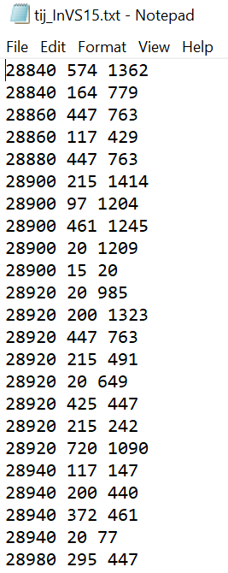
Figure 11: Dataset File Screenshot

I first import all the libraries required.

Code Segment 1: Imports

My next step is to load my dataset file from Google Drive as a dataframe.

Code Segment 2: Loading Dataset

Exploratory Data Analysis
Before beginning to program my simulation, I performed some basic analysis of the dataset to gain a better understanding of it and gain some metrics.

Average Contacts per Timestep:
This code is iterating through the dataset, recalling all contacts with a timestamp equal to t, and adding the timestamp as well as how many contacts were recalled to an array. It then averages the number of timesteps and outputs it, which is 1.57/20s.

This gives me an idea of the density of contacts in the network with respect to time.

Code Segment 3: Average Contacts per Timestep

Contacts per Timestep Frequency Graph:
This code takes the array containing timestamps and the number of contacts within them from before, sorts them in ascending order, and then graphs the values of contact frequency.
Code Segment 4: Contacts per Timestep Frequency Graph
This graph shows that though there are an average of 1.57 contacts per timestep, the majority of timesteps in the dataset are empty, with a minority of timesteps having upwards of 15 or 20 contacts. This sparsity of contacts in most of the dataset gives the idea that most of the infections will occur in certain hyperactive periods and the remaining inactive periods will offer a respite with unimpeded recovery.

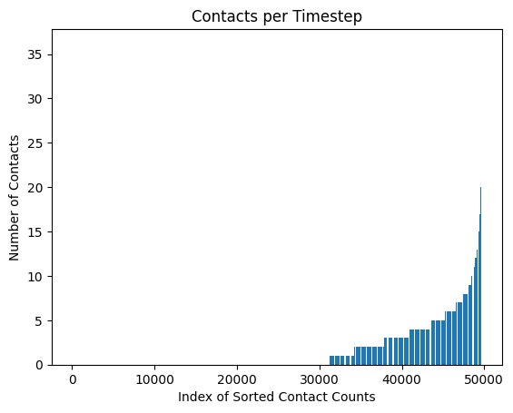
Figure 12: Contacts for each timestep (ascending)

Blank Timesteps Between 2 Timesteps:
This code is using the contact_count array from the last 2 code portions and summing the number of timestamps with 0 contacts between two timestamps.

Code Segment 5: Blank Timesteps Between 2 Timesteps

Contacts Aggregate Between 2 Timesteps:
This code is summing the number of contacts from between two timesteps.

Code Segment 6: Contacts Between 2 Timesteps

Using the above two code segments, I checked how many blank timesteps and contacts there were in each day of the dataset. To find where each day started and ended in terms of their timestamp value, I just scrolled through the dataset and noted the values of the big gaps between timestamps. The following table shows the results of my findings (plus an extra column I calculated later).

Table 1: Daily Contacts Summary
Day | Start Time | End Time | Blank Timestamps | Contacts | Average Infections
1 (Monday) | 28840 | 71980 | 26 | 12162 | 11.43
2 (Tuesday) | 115220 | 158380 | 60 | 8254 | 12.78
3 (Wednesday) | 201620 | 244780 | 101 | 6904 | 14.07
4 (Thursday) | 288020 | 328260 | 194 | 8455 | 19.42
5 (Friday) | 375180 | 415020 | 421 | 7738 | 23.98
6 (Monday) | 633620 | 676700 | 396 | 7252 | 16.9
7 (Tuesday) | 719700 | 761520 | 311 | 9129 | 22.12
8 (Wednesday) | 807300 | 846740 | 375 | 4677 | 10.21
9 (Thursday | 892820 | 935860 | 354 | 7941 | 12.15
10 (Friday) | 979440 | 1022380 | 277 | 5733 | 5.59
Totals | N/A | N/A | 2515 | 78245 | 148.65

Network Properties
This section will go over the results of the network metrics discussed in 2.4, and explain what their values mean for spreading behaviour. The code will not be given for all the metrics as most of them are single lines and therefore quite redundant. A summary of overall network metrics will be given in the following table.

Table 2: Network Metrics
Network Property | Value
Average Clustering Coefficient | 0.38
Average Degree | 39.39
Components | 1
Degree Assortativity | 0.0437
Transitivity | 0.356
Diameter | 5
Radius | 3
Unique Edges | 4929

Temporal Betweenness and Closeness Centralities

Details of temporal closeness and betweenness are explained in detail in 2.4.1 and 2.4.2, but what these show is how close a node is to all other nodes on average and how often a node lies in the shortest path between other nodes respectively.

The Pathpy library comes with these methods built in so they can be produced with a single line:
Code Segment 7: Centralities
My reasoning for choosing 22000 (6hrs 6mins) as my delta (the maximum timestamp gap between contacts in a path) was due to memory limitations, as the higher the delta, the more paths possible paths there are between nodes which need to be computed. This was the highest I could go without my runtime crashing, even with 53GB system RAM and 23GB GPU RAM on L4 GPU in Colab.

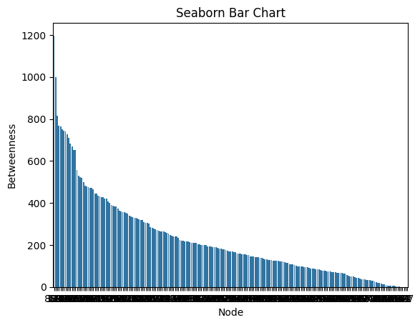
Figure 13: Betweenness centralities for each node
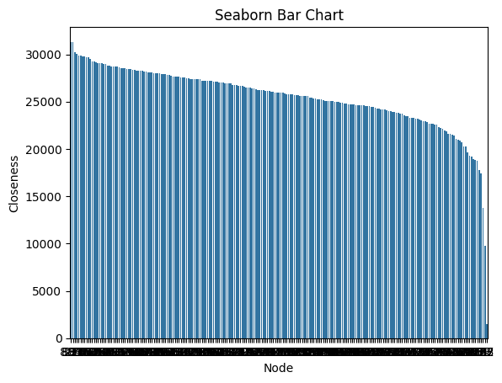
Figure 14: Closeness centralities for each node
As can be seen in the two graphs, the betweenness centralities in this network are for more skewed than the closeness centralities.

A long tailed distribution of betweenness but fairly even distribution of closeness shows that most nodes can reach other nodes in roughly the same amount of time, but there are nodes within the network that act as hubs or gatekeepers to infection paths. These nodes could be considered as “super spreaders” within a viral spread simulation, and when it comes to simulating immunisation, these would likely have the highest effect on reducing viral spread when vaccinated.

Radius and Diameter
A diameter of 5 and a radius of 3 shows the well connectedness of the network, congruent with what’s shown in the graph of closeness centralities. Even the farthest 2 nodes in the network are only 2 hops further away from each other than the radius. Such a network will not struggle to reach isolated or far nodes. However, this isn’t considering the temporal structure, so the reality could be different.

Transitivity
The transitivity of 0.356 shows a strong community structure within the network, which could evidence fast spreading amongst local groups.

Components
The graph consists of a single component, meaning that it is fully connected and that no matter where the spread begins from, every node could potentially be infected.

Degree Assortativity
There is a very slightly positive degree assortativity, meaning that there is a very small positive correlation between the degree of a node and the degree of its neighbour, but not an impactful one.

Simulation – Control Version

After my exploratory data analysis, I made the basic simulation with no interventions according to the framework outlined in Figure 4: Simulator Basic Structure Flow Chart. I made it incrementally starting with the blue far inner loop and adding to the orange part outside the loop, then adding the averaging across multiple runs in the purple outer loop.

Full code can be found in APPENDIX A – Basic Simulation Code. All following sections up to 4.10 will be adaptions of this base simulation

Metrics
This section will go over the metrics that are output after each simulation, and that will be the main basis for comparing the different intervention strategies.

Lowest, Average, Highest Peak Infected
Store the peak infected level for each run in an array, then output the average, minimum and maximum of the list.

Peak Infection Median Absolute Deviation
Outputs the mean absolute deviation for all peaks. This shows the typical deviation of a peak from the median peak and is a measure of spread which is less sensitive to outliers than standard deviation and is more effective in cases where the distribution of results is not normal. It is given by the following formula.
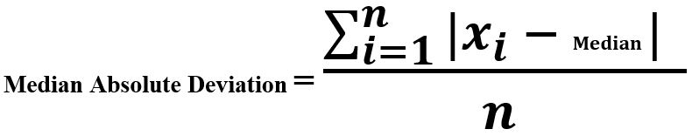
Figure 15: Median Absolute Deviation Formula

Epidemic Threshold Passing Probability
The proportion of the number of runs which passed a set threshold of stating that an epidemic did take place. This is set in my simulation at 20% of the population infected at the peak, which sounds arbitrary but may become clearer upon viewing the following figure.

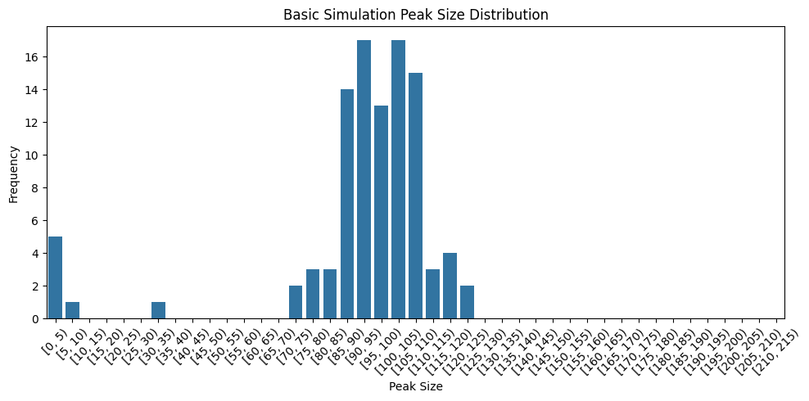
Figure 16: Peak Size Distribution
Seeing the graph, it becomes clear that this is a case of either the virus catches, or it doesn’t, where unless the virus never spreads beyond the initial infected, it is most likely going to tend very strongly towards the average.

Total Infected
The total infected throughout the simulation is calculated by adding up the final recovered and infected populations, and subtracting the number immunized from the beginning if any.

Missed Contacts
The number of missed contacts can be used to evaluate an intervention relative to how many contacts it misses, so an intervention with a higher total infected reduction per missed contact could be considered more effective.

Self-Isolation After X Days Infected for Y Days
The idea behind this intervention was to investigate different combinations of self-isolation time and incubation time to find the relationship between increasing and decreasing them relative to each other, and how the return in spread reduction diminishes with more days isolated, and how spread increases with increasing non-symptomatic infectious duration.

This was done by creating a dictionary called infection_time where, when a person was infected, their number would be added along with the time at which they were infected. They were then filtered from further contacts based on two parameters, which corresponded to how long after being infected they would self-isolate (i.e. incubation time), and how long they would self-isolate for respectively.
Code Segment 8: Infection Logic Updated for Self-Isolation

Code Segment 9: Node Status Updates Updated for Self-Isolation

Self-Isolation Until Recovered
Major health and disease control authorities don’t typically recommend a specific number of days to stay home when infected with a respiratory virus, but typically recommend for you to return to normal activities 24hrs after symptoms have begun to recover (CDC, 2024). Therefore, it is a distinctly important intervention to test compared to the one in the previous section. This is also an easier intervention to trial and to combine with other intervention’s since it only has a singular parameter of incubation time and not time to self-isolate.

The logic is implemented very similarly to the previous chapter, but with a slight modification to the function that checks for contact suppression.

Code Segment 10: Contact Suppression Function for Self-Isolate Until Recovered
The function first checks that the person is infected. If this condition is true, then if the length of the incubation time has passed since becoming infected, with the person still being infected, the contact is suppressed.

Hybrid Working
In a recent survey by CIPD (2023), an astounding 83% of organisations reported having a hybrid work, policy, with over half having a minimum number of days per week in-person attendance, making this an intervention that has great relevance to real world working conditions.

This was done by way of a simple conditional statement in the infection logic block which bypasses every contact within a specified range of timesteps.
Code Segment 11: Hybrid Working Infection Logic
In this project, I will be comparing 3 hybrid working schedules: Thursday and Friday off, Tuesday and Thursday off and Tuesday and Wednesday off. This is to compare the effectiveness between many contiguous days of contact reduction (for Thursday and Friday hybrid days), more distributed contact reduction (Tuesday and Thursday hybrid days), and something in between (Tuesday and Wednesday hybrid days).

Self-Isolation Until Recovered and Hybrid Working
With the prevalence of hybrid working in modernity, this may be the most realistic set of conditions for a typical organisation. This intervention will show the effects of combining two interventions and what their combined effect may be. Perhaps it could lead to diminished returns, or conversely to a compounding increase.

The logic for this was created by adjusting the is_suppressed function to filter timestamps as the initial conditional statement.

Code Segment 12: Self Isolation and Hybrid Working Suppression Function

Targeted Immunisation
In order to study the effect of “super-spreader” phenomena, I trialled immunising the top 20 and bottom 20 temporal betweenness centrality nodes, choosing betweenness because it had the most variance between the minimum and maximum to in theory produce a more observable effect. Another trial with 20 random nodes vaccinated per run was also performed as a control.

This was achieved in the simulation by initialising their SIR states as Recovered.

Code Segment 13: Vaccination SIR Initialisation

Shuffled Timestamps
The aim of shuffling the timestamps in the dataset is to observe the effect of destroying the topology of the network, while still preserving the same individual contacts and keeping the same number of contacts at each timestamp as before the transformation. This approach is based on a similar trial performed by Rocha (2011).

Static Network Simulation
This simulation flattens the temporal network to a static one, and gives each edge in the network a weight based on the number of contacts across that edge throughout the temporal network. The simulation runs for the same number of time steps as the temporal network, and at each iteration, each edge has a probability of being active based on its weight, such that for one simulation run, each edge will have the same number of contacts as in the original temporal network on average. This approach is adapted from one used by Rocha (2011)

This static network approach keeps the topological structure, but destroys the temporal structure of the network.

Full code can be found in APPENDIX C – STATIC NETWORK SIMULATION

Evaluation of Artefact (Following from Appendix D)

Fulfilment of Aims

To understand the dynamics of viral spread in a temporal contact network using time-respecting SIR simulations, and investigate the effect of temporal structures on viral spread

The project set out to understand the dynamics of viral spread in a temporal contact network using time-respecting SIR simulations, with a particular focus on how the timing and structure of interactions affect transmission patterns. By simulating the spread of infection over real contact sequences, I was able to observe how key temporal features—such as burstiness, and delays, and even the regular 5 day work week—can significantly alter outbreak size, peak infection times, and the effectiveness of interventions. Even the simplest elements of human life and interaction, like that we’re awake in the day and sleep at night, are missed completely without some kind of time reference, demonstrating that static network models may underestimate or misrepresent the true dynamics of disease propagation.

To evaluate the effectiveness of different viral spread mitigation strategies.
The real-life applications of the NPIs (non-pharmaceutical interventions) covered in this project would be that if a company were to add only a self-isolation policy, they would lose many contact hours from people having to stay at home, and it likely wouldn’t reduce infections by much.

A hybrid work policy would do a huge amount to reduce infection, even if infectious people didn’t stop coming to work, and the schedule can be chosen with respect to what your priorities may be in your organisation (gradual peak vs reduced infections).

A hybrid work policy, when combined with self-isolation makes for a perfect solution. Blanket hybrid working acts as a pre-emptive measure by reducing contacts generally, and targeted self-isolation catches any stragglers without having half your office stuck at home like it would be if it was used on its own.

Fulfilment of Objectives

Objective 1: Understand and analyse viral spread in temporal networks |  | Completed
S | By simulating viral spread in different network structures | Done
M | Using at least 3 different network structures | Temporal Network, Static Network, Shuffled Temporal Network
A | Using existing temporal network data and network techniques | Sociopatterns public dataset and network science techniques utilised
R | In order to inform intervention design and understand the effect of temporal structure on viral spread. | The relation between temporal structure and the effects of interventions has been explained
T | Aiming to build on this throughout the project. | Done

Objective 2: Develop and evaluate viral spread mitigation strategies within the simulation |  | Completed
S | By adding them as modifications to my simulation code, their primary function in the code being to conditionally skip contacts. | Done for all NPIs
M | Implementing at least 3 different mitigation strategies | Self-isolation, Hybrid work, Hybrid + self-isolation, vaccination
A | Based off existing and feasible to implement strategies. | All mitigation strategies have a basis in literature.
R | In order to understand their effectiveness and to inform my conclusions on what policies would be best implemented by a school or workplace. | Final conclusions explained with data to justify.
T | Aiming to complete this by the 14th of April. | Completed on 1st of May

Objective 3: Provide insights for real world applications |  | Completed
S | Critically evaluate the different mitigation strategies trialled in the simulation and comment on the impact of my findings on how it impacts for real world sickness policies. | Completed
M | Using metrics from the simulation trial to justify my conclusions | Completed
A | Based off existing and feasible to implement strategies. | All NPIs are based on things that are common and feasible for an organisation to do with minimal investment.
R | In order to understand their effectiveness and to inform my conclusions on what policies would be best implemented by a school or workplace. | Completed
T | Aiming to complete this by the 5th of May. | Completed 14th of May

Conclusion and Reflection

Improvements
If I had to do the project over again from the beginning, I would begin coding earlier on, because after starting to make something, you always get ideas during it that didn’t occur when you were planning. This makes it so you end up in a rush to get all your ideas into the project, which ended up being me and this made me fall behind schedule.

I also realised towards the end that some of my code wasn’t programmed in the most efficient way to maximise execution speed, so where I was waiting 40 minutes for something to execute, I could have waited less time and therefore worked more efficiently. So if I were to do it again, I would put a focus on quality and efficient code from the start.

Limitations
This project has been done mostly from my laptop and executed on the Google Colab cloud environment. With more knowledge and computational power I could have created some visualisations for the viral spread which are sorely lacking in this project.

Visualisations would have allowed me to deepen my understanding of the paths by being able to actually watch the paths taken by the virus as it traverses the network, as well as better convey the ideas expressed in this report to the reader.

However, my research into what was available in Python that I could integrate easily into my existing code didn’t bear fruit, and to learn a whole different set of technologies for visualisations was outside the scope of this project

Future Work
The next step from this project could be to investigate the paths, themselves and how they branch. Which paths are most common, which cause the most infections, when you block one path of infections, how does the stream diverge? These are very interesting questions and they lie at the very heart of network science.

Word count (main body of the report excluding tables): 5846

References
Alimohamadi, Y., Taghdir, M. and Sepandi, M. (2020). The Estimate of the Basic Reproduction Number for Novel Coronavirus Disease (COVID-19): a Systematic Review and Meta-Analysis. Journal of Preventive Medicine and Public Health, 53(3). doi: https://doi.org/10.3961/jpmph.20.076

Beauchamp, M.A. (1965). An improved index of centrality. Behavioral Science, 10(2), pp.161–163. doi: https://doi.org/10.1002/bs.3830100205

‌ Buß, S., Molter, H., Niedermeier, R. and Rymar, M. (2024). Algorithmic aspects of temporal betweenness. Network Science, 12(2), pp.160–188. doi: https://doi.org/10.1017/nws.2024.5

CDC (2024). About Preventing Spread of Respiratory Viruses When You’re Sick | Respiratory Illnesses | CDC. [online] www.cdc.gov. Available at: https://www.cdc.gov/respiratory-viruses/prevention/precautions-when-sick.html

CIPD. (2021). CIPD | Employers urged to address high levels of people working when unwell. [online] Available at: https://www.cipd.org/uk/about/news/employers-urged-address-high-levels-presenteeism/.

CIPD (2023). Flexible and hybrid working practices in 2023. [online] CIPD. Available at: https://www.cipd.org/uk/knowledge/reports/flexible-hybrid-working-2023/

Euler, L. (1768). Institutionum calculi integralis.

Ferguson, N.M., Laydon, D., Nedjati-Gilani, G., Imai, N., Ainslie, K., Baguelin, M., Bhatia, S., Boonyasiri, A., Cucunubá, Z., Cuomo-Dannenburg, G. and Dighe, A., 2020. Impact of non-pharmaceutical interventions (NPIs) to reduce COVID-19 mortality and healthcare demand. Imperial College London. DOI: 10.25561/77482

Holme, P. and Saramäki, J., 2012. Temporal networks. Physics Reports, 519(3), pp.97–125. https://doi.org/10.1016/j.physrep.2012.03.001

HSE., circa 2022. Health and Safety Executive: Coronavirus (COVID-19) disease reports made by employers since 10 April 2020 [online]. www.hse.gov.uk. Available from: https://www.hse.gov.uk/statistics/coronavirus/index.htm.

Jung, Y., Wilson, K.T. and Wilson, A.M. (2025). Could hybrid work schedules offer infection risk reductions? Insights from a CO2 sensor and modeling study. Building and Environment, 276, p.112878. doi: https://doi.org/10.1016/j.buildenv.2025.112878

Kermack, W.O. and McKendrick, A.G., 1927. A contribution to the mathematical theory of epidemics. Proceedings of the Royal Society A, 115(772), pp.700–721. https://doi.org/10.1098/rspa.1927.0118

Klepac, P., Kucharski, A.J., Conlan, A.J., Kissler, S., Tang, M.L., Fry, H. and Gog, J.R., 2020. Contacts in context: large-scale setting-specific social mixing matrices from the BBC Pandemic project. medRxiv. https://doi.org/10.1101/2020.02.16.20023754

Koo, J.R., Cook, A.R., Park, M., Sun, Y., Sun, H., Lim, J.T., Tam, C. and Dickens, B.L., 2020. Interventions to mitigate early spread of SARS-CoV-2 in Singapore: a modelling study. The Lancet Infectious Diseases, 20(6), pp.678–688. https://doi.org/10.1016/S1473-3099(20)30162-6

Masuda, N. and Holme, P., 2017. Temporal network epidemiology. Springer. https://doi.org/10.1007/978-981-10-5287-3

Mauras, S., Cohen-Addad, V., Duboc, G., Dupré la Tour, M., Frasca, P., Mathieu, C., Opatowski, L., & Viennot, L., 2021. Mitigating COVID-19 outbreaks in workplaces and schools by hybrid telecommuting. PLoS computational biology, 17(8), e1009264. https://doi.org/10.1371/journal.pcbi.1009264

Pan, R.K. and Saramäki, J., 2011. Path lengths, correlations, and centrality in temporal networks. Physical Review E, 84(1), p.016105. https://doi.org/10.1103/PhysRevE.84.016105

Rocha, L.E.C., Liljeros, F. and Holme, P. (2011). Simulated Epidemics in an Empirical Spatiotemporal Network of 50,185 Sexual Contacts. PLoS Computational Biology, 7(3), p.e1001109. https://doi.org/10.1371/journal.pcbi.1001109

Stehlé, J., Voirin, N., Barrat, A., Cattuto, C., Isella, L., Pinton, J.-F., Quaggiotto, M., Van den Broeck, W., Régis, C., Lina, B. and Vanhems, P. (2011). High-Resolution Measurements of Face-to-Face Contact Patterns in a Primary School. PLoS ONE, 6(8), p.e23176. doi: https://doi.org/10.1371/journal.pone.0023176

Tanaka, H., Ogata, T., Shibata, T., Nagai, H., Takahashi, Y., Kinoshita, M., Matsubayashi, K., Hattori, S. and Taniguchi, C. (2022). Shorter Incubation Period among COVID-19 Cases with the BA.1 Omicron Variant. International Journal of Environmental Research and Public Health, 19(10), p.6330. doi: https://doi.org/10.3390/ijerph19106330

Valdano, E., Ferreri, L., Poletto, C. and Colizza, V., 2015. Analytical computation of the epidemic threshold on temporal networks. Physical Review X, 5(2), p.021005. https://doi.org/10.1103/PhysRevX.5.021005

Walsh, K.A., Spillane, S., Comber, L., Cardwell, K., Harrington, P., Connell, J., Teljeur, C., Broderick, N., de Gascun, C.F., Smith, S.M., Ryan, M. and O’Neill, M. (2020). The duration of infectiousness of individuals infected with SARS-CoV-2. Journal of Infection, [online] 81(6), pp.847–856. doi: https://doi.org/10.1016/j.jinf.2020.10.009

Zaki, N. and Mohamed, E.A. (2021). The estimations of the COVID-19 incubation period: A scoping reviews of the literature. Journal of Infection and Public Health, [online] 14(5), pp.638–646. doi: https://doi.org/10.1016/j.jiph.2021.01.019

‌

APPENDIX A – Basic Simulation Code

APPENDIX B – PROJECT PROPOSAL

Project Proposal Form
Please refer to the Project Handbook Section 4 when completing this form
Degree Title:  Computer Networks | Student’s Name:  Shahir Ali
Degree Title:  Computer Networks | Supervisor’s Name:  Wei Koong Chai
Degree Title:  Computer Networks | Project Title/Area:  Simulating Virus Spread and Mitigation Strategies in Temporal Networks

Section 1: Project Overview
1.1 Problem definition - use one sentence to summarise the problem:
The risk of people coming into the office/school when infectious which can potentially cause an epidemic in the organisation.

1.2 Project description - briefly explain your project:
To investigate viral spread and measures against it that can be implemented in places such as schools and workplaces using simulations on contact datasets modelled as temporal networks. These preventative measures will be focused on changes in behaviour, such as hybrid working

1.3 Background - please provide brief background information, e.g., client, problem domain:
In a 2018 survey by CIPD, 86% of UK workers said that they had observed people coming into work ill at their organization in the last 12 months, compared to 72% in 2016 and just 26% in 2010 (CIPD, 2021)
. Furthermore, the UK’s Health and Safety Executive stated that 123,000 workers diagnosed with COVID-19 in 2021/22 believed they were exposed to the virus at work.

This work culture of feeling pressured to come in when having an infectious illness, like the cold, flu or even COVID-19, presents a serious public health concern, and has the potential to start an “office epidemic”, resulting in significant loss of productivity, and of course unneeded suffering.

1.4 Aims and objectives – what are the aims and objectives of your project?
My objectives are:
- Understand and analyse viral spread in temporal networks.
- Model and simulate viral spread processes.
- Develop and evaluation mitigation strategies.
- Quantify the impact of network topology and dynamics.
- Provide insights for real-world applications.
- Deliver a comprehensive report on findings.

Section 2: Artefact
2.1 What is the artefact that you intend to produce?
My artefacts are the viral spread simulator with a report on its creation and the data on spreading behaviour that my model will produce. My final artefact will include a report exploring and interpreting the results of my viral spread mitigation strategies that are implemented in the simulation.

2.2 How is your artefact actionable?
I can inspect the network and nodal properties within the simulation before and after enacting the countermeasures to determine their reductive effect on viral spread, alongside epidemiological metrics such as basic reproduction rate. These results could be used to inform a school or workplace’s policies on what their employees/students should do when they are sick or inform government policies on what workplaces should do during a pandemic.

Section 3: Evaluation
3.1 How are you going to evaluate your work?
I can compare the spreading behaviour (using metrics such as basic reproduction rate, maximum infection level, time to max infection level, and others) displayed in my model with absentee data which is associated with some of the contact datasets I have found (data that shows the number of people who called in sick on each day during an epidemic). There is also a considerable body of work in this subject area, so there are many studies and models that I can compare my simulator, data and conclusions to.

However, there is still a challenge in that many contact network datasets available do not have associated epidemic data, and so I will not always have a good “ground truth” to evaluate upon.

3.2 Why is this project honours worthy?
The topic of my project is key in solving real-world problems, a problem that was realised in the COVID-19 pandemic. The multidisciplinary nature of my project, which lies on the intersection of computer, network and health sciences makes my project both academically challenging and broadly impactful and meets the standards of honours-level research. My project also has several high quality artefacts which can be produced and delivered as evidence of my work.

3.3 How does this project relate to your degree title outcomes?
My simulator will use networks to model the contacts between people, abstracting the people as nodes and contacts as edges. This will directly utilise my knowledge from my Advanced Networks unit which goes over the elements of graph theory.

3.4 How does your project meet the BCS Undergraduate Project Requirements?
The BCS requirements specify some practical work using computing/IT technology being undertaken, which I am fulfilling. The requirements also specifies a report to be completed with specific sections included in it, which my project will allow me to complete.

3.5 What are the risks in this project and how are you going to manage them?
The biggest impact risk in my project is that I am unable to create my simulator, as the rest of my project is contingent on using simulation results. The likelihood of this coming about is low as there are many tools available to me to use for support in making the simulator. If it does happen, I could use a different pre-existing simulator instead of making my own to perform my experiments.

Another risk is making oversimplified or inaccurate assumptions which would lead to my simulation not being accurate to real life. This risk would have a major impact with a considerable likelihood of occurring. In order to prevent this from happening, the first step of my project will be to conduct an extensive literature review and give myself a full understanding of the problem domain.

Other risks include lack of sufficient data and lack of processing power. I will address these risks and more in a risk analysis table in my report.

Section 4: References
4.1 Please provide references.
CIPD., 2021. CIPD | Employers urged to address high levels of people working when unwell [online]. CIPD. Available from: https://www.cipd.org/uk/about/news/employers-urged-address-high-levels-presenteeism/.
HSE., circa 2022. Health and Safety Executive: Coronavirus (COVID-19) disease reports made by employers since 10 April 2020 [online]. www.hse.gov.uk. Available from: https://www.hse.gov.uk/statistics/coronavirus/index.htm.

Section 5: Proposed Plan (please attach your Gantt chart below)

APPENDIX C – Static Network Simulation Code

APPENDIX D – Analysis of SImulation Results (Artifact)
This section will cover the results of all the interventions and trials mentioned in section 4, with each being critically evaluated

Control
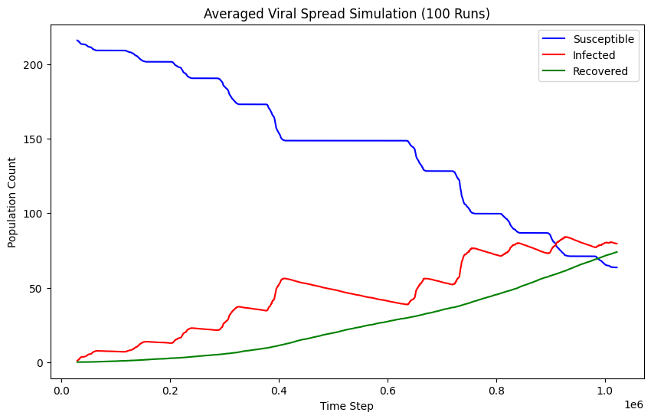
Figure 18: Control SIR Graph

Table 3: Control Simulation Results
Simulation Metrics (100 Runs) | Control
Average Peak Infected | 81.73
Peak Percentage Decrease Over Control | 0.0
Peak Infection Percentage Decrease Per Missed Contact | N/A
Average Peak Time | 927140
Highest Peak Infected Count | 130
Lowest Peak Infected Count | 1
Infected Count Median Absolute Deviation | 10
Epidemic Threshold Passing Probability | 0.95
Total Infected | 162.51
Total Infected Percentage Decrease Over Control | 0.0
Total Infected Percentage Decrease Per Missed Contact | N/A
Missed Contacts | 0
Final Infected Count | 76.41

Starting with the graph, it is clear to see the effects of temporal structure on viral spread. Each weekday follows an on/off structure in the spreading, corresponding to hours in and out of work. There is also a long period of respite in the weekend days giving time for unimpeded recovery. It is also visible from the red line the relationship between the number of infected on a given day and the number of subsequent infections cause, in a kind of positive feedback loop. This pattern will emerge in each of the temporal network simulations. Infections appear highest on the first Friday and the second Tuesday, but after the second Tuesday the rising level of recovered impedes the rate of infection, though the peak is still very high at over 37% of the population.

Moving onto the table, the lowest peak can be seen out of 100 runs can be seen at just 1, meaning there were no subsequent infections in that run at all. This is a result of the stochastic nature of the simulation, and it means that the first infected recovered before they were able to infect anybody. However, Figure 16 shows very few peaks above the 0-5 range and below 70. This implies that so long as the initial infected is able to get just a couple of infections, an epidemic is highly likely.

Table 4: Average Subsequent Infections
Node | Avg Subsequent Infections
574 | 2.05
1362 | 2.38
164 | 1.64
779 | 1.73
447 | 3.09
763 | 1.84
215 | 5.84
1414 | 2.96
97 | 5.00
1204 | 4.07
Average (R₀) | 3.06

The basic reproduction rate (R₀) is defined as being the number of subsequent infections caused by the initial infected group per person. Table 4 shows the average subsequent infections for each of the candidate first infected nodes which are selected randomly at the beginning of each trial. Taking the average of these gives us a value of 3.06, which is valuable in a couple of ways.

Firstly, it tells us that the simulated virus does have the capability of causing epidemic, as only when the R₀ of a virus is above 1 can it multiply. Secondly, it tells us that our assumptions for infection and recovery rates are within reasonable bounds, since this value of R₀ is similar to that that of COVID-19 in the literature (Alimohamadi et al., 2020).

Self Isolation After X Days Infected for Y Days

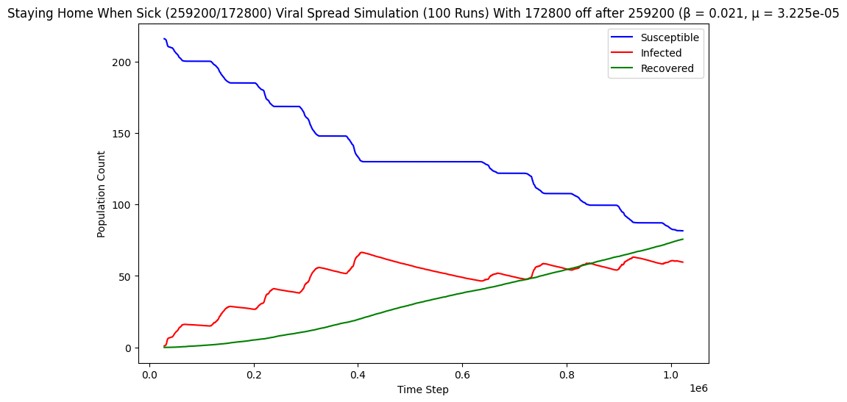
Figure 19: Self-Isolation (3 days off, 3 days incubation) SIR Graph
This graph is an example of one of my self-isolation simulation trials, but there are 16 with the values of isolation period and incubation time varying between 1 and 4 days. The first change that can be seen is that the peak has moved from very close to the end in the control to right near the beginning following intervention. The shape of the Infected line in the first week of the simulation has not changed much, but the second week is much flatter than before.

Because of the incubation time, it takes some days for the intervention to show effect, so this may be the cause. In the previous section it was mentioned how the increasing number of infected accelerated the viral spread, but by way of this intervention, that has been stopped entirely.

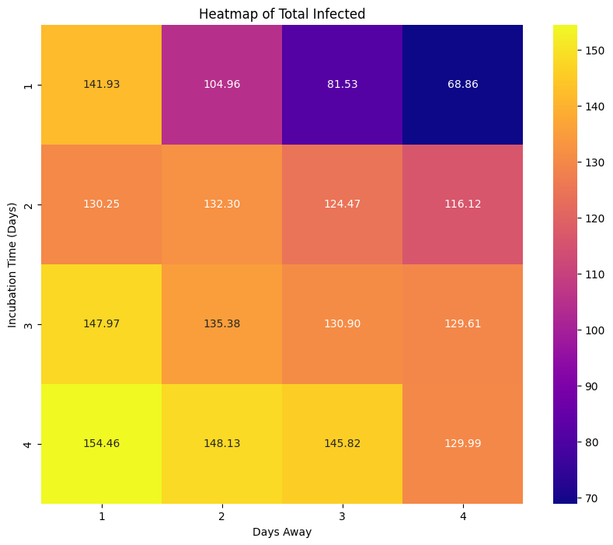
Figure 20: Heatmap of Total Infected (Self Isolation)
Figure 19 shows the average total infected based on the combination of incubation time and isolation period. As is evident, minimum incubation time and maximum days off gives the lowest infections and vice versa, but it is noteworthy how much more impactful the incubation time is compared to isolation period in the simulation.

The explanation for this is twofold. One is that the earlier a node self-isolates, the more likely it is that it will recover before it’s ever had a chance to infect someone else. The other is that in an epidemic setting, the earlier an infection occurs, the greater the impact it has because that infected person then has more time to infection someone else. If it self-isolates on day 2 of infection and returns on day 5, it might infect someone on day 6. But if it self-isolates on day 4 of infection and returns on day 7 it has much more time to infect someone early in the first 3 days.

Self-Isolation Until Recovered

Table 5: Self Isolation Until Recovered Metrics
Simulation Metrics / Incubation Time (Days) | Control | 1 | 2 | 3 | 4 | 5
Average Peak Infected | 81.73 | 21.97 | 62.34 | 64.3 | 71.08 | 70.59
Peak % Decrease Over Control | 0.0 | 73.1 | 23.7 | 21.3 | 13.0 | 13.6
Peak % Decrease per Missed Contact | N/A | 0.00012 | 0.00014 | 0.000246 | 0.000377 | 0.0006
Highest Peak Infected Count | 130 | 74 | 118 | 129 | 125 | 126
Lowest Peak Infected Count | 1 | 1 | 1 | 1 | 1 | 1
Infected Count Median Absolute Deviation | 10 | 19 | 20.5 | 25.5 | 18 | 12.5
Epidemic Threshold Passing Probability | 0.95 | 0.27 | 0.72 | 0.74 | 0.85 | 0.92
Total Infected | 162.51 | 32.03 | 81.77 | 101.41 | 126.2 | 142.38
Total % Decrease Over Control | 0.0 | 80.3 | 49.7 | 37.6 | 22.3 | 12.4
Total % Decrease per Missed Contact | N/A | 0.00931 | 0.00351 | 0.003086 | 0.002104 | 0.0016
Missed Contacts | 0 | 8619.49 | 14138 | 12183.38 | 10619.81 | 7975.6
Final Infected Count | 76.41 | 8.14 | 23.07 | 37.68 | 49.38 | 62.95

A curiosity here is that the Missed Contacts row seems to follow a kind of bell-curve shaped distribution. However, upon thinking about it, it is actually quite rational. Early self-isolation leads to each infected person being isolated for a long time, but with few total infections. Late self-isolation leads to each infected person being isolated only for a short time because they are close to recovering by the time they start to self-isolate since they were so late, but there are many infected. This leads to short and long incubation times having a similar number of missed contacts. However, there is a sweet spot in the middle where there are a considerable number that are infected, and they isolate early enough that they’re gone for a while. This midway point causes maximum disruption

Self-isolation until recovered follows the same trend as in the previous section, with 1 day incubation time being far better in terms of performance. Self-isolating after 1 day of infectiousness has very significant improvements over the control in all metrics, but a 1 day incubation period is not very realistic for most respiratory viruses. For a 5 day incubation period as with the COVID-19 alpha variant, there is only marginal decrease in metrics such as highest peak and epidemic threshold passing probability, 13.6% less peak infected and 12.4% less total infections, whilst missing about 10% of contacts. It does minimise peak reduction over control per missed contact but has the worst total infection reduction per missed contact, the reason behind both of these phenomena I am unsure about.

Therefore in the case of a disease with a long asymptomatic infectious period, self-isolation of nodes only following infection cannot be considered effective, as by the time a person realises they are infected, they may already have caused numerous infections.

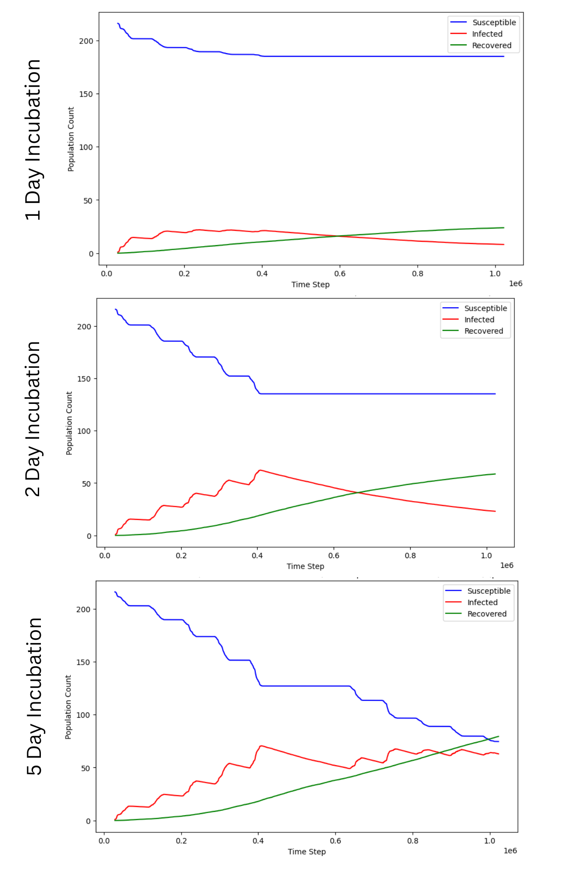
Figure 21: 1 Day vs 2 Day vs 5 Day Incubation Self-Isolation SIR Graph
This conclusion becomes evident upon comparing the graphs. A 1 day incubation period causes the epidemic to never really pick up, at 3 days, the graph is quite similar to the control in the first week but in the second week recovery outpaces new infections for quite a visible improvement, but with a 5 day incubation period, there is not a major improvement over the control.

Hybrid Working

Table 6: Hybrid Working Metrics
Simulation Metrics (100 Runs) | Control | Thu/Fri Hybrid | Tue/Thu Hybrid | Tue/Wed Hybrid
Average Peak Infected | 81.73 | 47.56 | 68.83 | 41.64
Peak % Decrease Over Control | 0.0 | 41.8 | 15.8 | 49.1
Peak Infection % Decrease Per Missed Contact | N/A | 0.001400 | 0.000467 | 0.001694
Highest Peak Infected Count | 130 | 102 | 111 | 88
Lowest Peak Infected Count | 1 | 1 | 1 | 1
Peak Infected Median Absolute Deviation | 10 | 25.5 | 11 | 19
Epidemic Threshold Passing Probability | 0.95 | 0.62 | 0.81 | 0.66
Total Infected | 162.51 | 79.81 | 118.78 | 84.2
Total Infected % Decrease Over Control | 0.0 | 50.9 | 26.9 | 48.2
Total Infected % Decrease Per Missed Contact | N/A | 0.00170 | 0.00080 | 0.00166
Missed Contacts | 0 | 29867 | 33779 | 28964
Final Infected Count | 76.41 | 35.22 | 67.89 | 41.18

The findings of this intervention are of some great interest. Similar to the conclusions of Mauras et al. (2021) the little-and-often approach of hybrid scheduling was the worst, however, the schedule that was halfway in contiguousness between the 3 was close very well matched with the one with most contiguous days off.

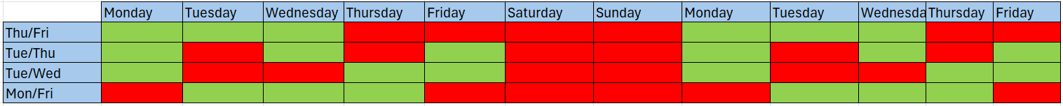
Figure 22: Hybrid Schedule Diagram
To better explain what I mean, consider the preceding diagram. Each schedule has 6 days in-office and 6 days away-from-office, but Tue/Thu has the 6 days off in 5 chunks, Tue/Wed in 3 chunks and Thu/Fri in 2 chunks.

The table of results shows that Tue/Wed excels over Thu/Fri in reducing the peak, likely due to it having no more than 2 contiguous in-office days in the simulation for infected level to snowball, and that Thu/Fri excels over Tue/Wed in reducing the total infections, explained by the 4 continuous days off which give a long respite for unimpeded recovery.

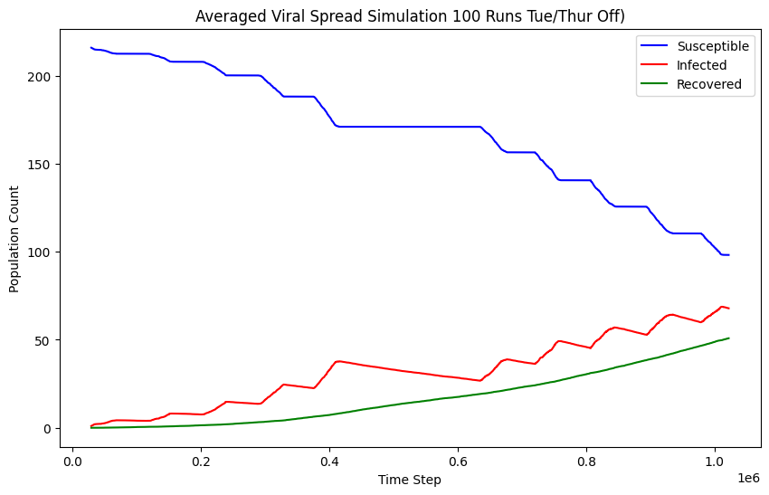
Figure 23: Tue/Thu Hybrid SIR Graph
A potential advantage of the Tue/Thu Hybrid schedule is that it greatly delays the peak. This could be acceptable in certain settings where a large number of total or peak infections is preferable to a sudden spike of infections, even a small one, so it definitely still has a place.

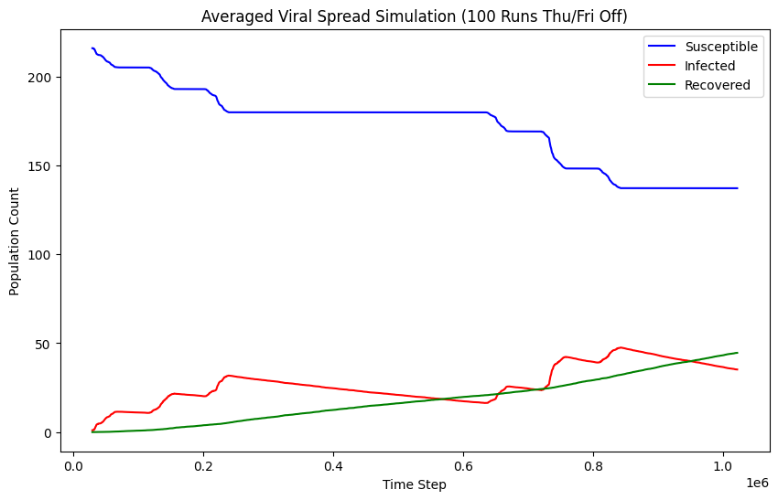
Figure 24: Thu/Fri Hybrid Graph
The Thu/Fri Hybrid schedule has more contiguous days in-office which leads to a sharper peak in the second week compared to Tue/Thu, but less infections overall.

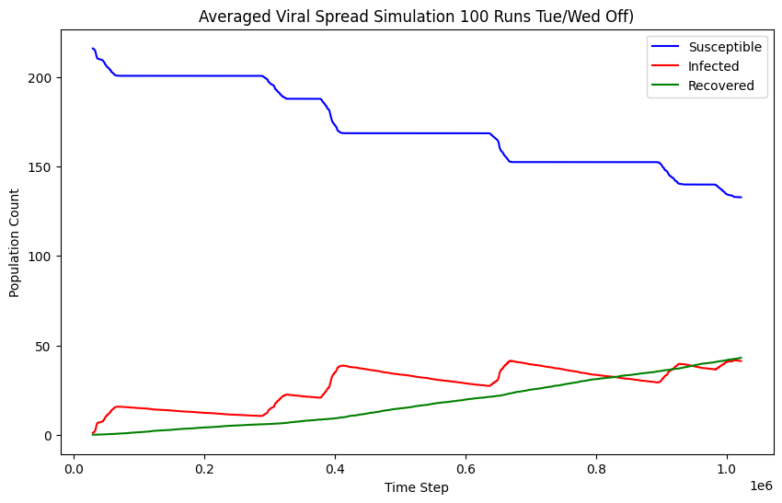
Figure 25: Tue/Wed Hybrid Schedule
Tue/Wed Hybrid schedule has a smoother and more gradual slope than Thu/Fri and yet allows more continuous recovery time than Tue/Thu, which could make for an ideal middle ground for organisations wanting a middle ground between gradual peaks and minimised infections.

Self-Isolation and Hybrid Working
This section will only cover a single Hybrid strategy and not all of them as it is sufficient to portray the effect of combining the two mitigation strategies.
Simulation Metrics | Control | Tue/Wed - 1 | Tue/Wed - 2 | Tue/Wed - 3 | Tue/Wed - 4 | Tue/Wed - 5
Average Peak Infected | 81.73 | 15.67 | 16.66 | 24.04 | 39.42 | 42.23
Peak % Decrease Over Control | 0.0 | 80.8 | 79.6 | 70.6 | 51.8 | 48.3
Peak % Decrease per Missed Contact | N/A | 0.00257 | 0.00251 | 0.00216 | 0.00159 | 0.00152
Highest Peak Infected Count | 130 | 50 | 55 | 81 | 101 | 96
Lowest Peak Infected Count | 1 | 1 | 1 | 1 | 1 | 1
Peak Median Absolute Deviation | 10 | 10.5 | 9.5 | 19.5 | 28.11 | 24.5
Epidemic Threshold Passing Probability | 0.95 | 0.05 | 0.08 | 0.25 | 0.56 | 0.62
Total Infected | 162.51 | 16.48 | 17.22 | 37.28 | 70.91 | 77.36
Total % Decrease Over Control | 0.0 | 89.9 | 89.4 | 77.1 | 56.4 | 52.4
Total % Decrease per Missed Contact | N/A | 0.00286 | 0.00282 | 0.00235 | 0.00173 | 0.00165
Missed Contacts | 0 | 31426.59 | 31662.57 | 32750.97 | 32634.38 | 31808.08
Self-Isolation Missed Contacts | 0 | 2462.59 | 2698.57 | 3786.97 | 3670.38 | 2844.08
Final Infected Count | 76.41 | 3.45 | 3.57 | 11.34 | 28.11 | 33.82

The appearance of the heatmap is similar to 9.3, but there is markedly more order in the colours, and the MAD values are lower than with just the self-isolation on its own. This is likely simply due to less opportunities for contacts giving way to reduced stochasticity.

Incubation times of 1, 2 and 3 days have had a significant beneficial effect on top of hybrid working, adding upwards of 20% further decrease of peak infected level for just a few thousand missed contacts, which is an extreme return on investment.

Evaluation of NPIs (Non Pharmaceutical Interventions)

Targeted Immunisation
Table 7: Vaccinated Groups Metrics
Simulation Metrics (100 Runs) | Control | Top 20 Betweenness | Bottom 20 Betweenness | Random 20 | Top 20 Degree
Average Peak Infected | 81.73 | 52.03 | 76.32 | 65.52 | 53.9
Peak % Decrease Over Control | 0.0 | 36.3 | 6.6 | 19.8 | 34.1
Highest Peak Infected Count | 130 | 89 | 119 | 111 | 96
Lowest Peak Infected Count | 1 | 1 | 1 | 1 | 1
Peak Median Absolute Deviation | 10 | 10 | 8 | 11.5 | 15.5
Epidemic Threshold Passing Probability | 0.95 | 0.84 | 0.93 | 0.9 | 0.775
Total Infected | 162.51 | 103.5 | 150.95 | 131.88 | 104.4
Total % Decrease Over Control | 0.0 | 36.3 | 7.1 | 18.8 | 35.8
Final Infected Count | 76.41 | 50.53 | 71.59 | 62.09 | 51.67

There is assuredly a greater effect on viral spread reduction when immunising higher betweenness nodes, however, it is unclear whether that is due to blocking critical infection pathways, or whether it’s simply because the high betweenness nodes have many edges.

There are 9 nodes overlapping between top 20 betweenness and top 20 degree, with the remaining 11 nodes making only a very slight difference in the metrics. Further research would be needed than what is in the scope of this project to understand the true mechanisms behind what is primarily responsible for the decrease in spread.

However, my hypothesis is that in such a well-connected network, the shortest paths don’t hold much importance in viral spread, and that the sheer degree may be more impactful than where the edges go, because wherever you go you won’t be far from most places.

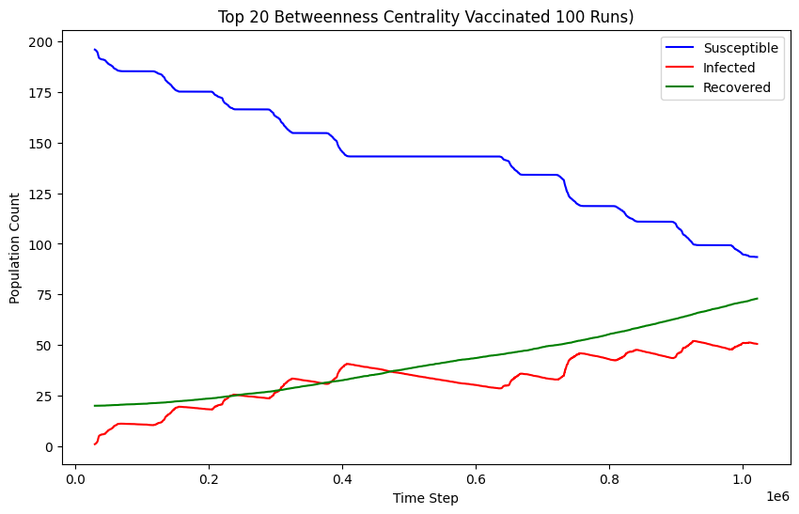
Figure 26: Top 20 Betweenness SIR Graph
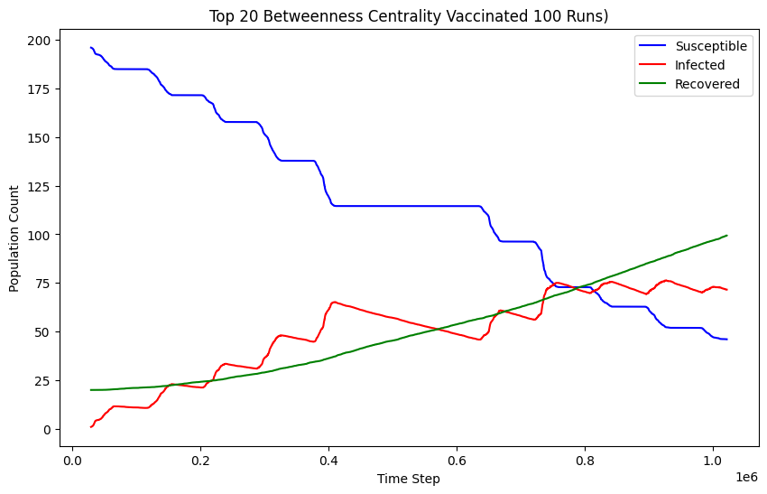
Figure 27: Bottom 20 Betweenness SIR Graph
The shape of the two graphs is quite similar, mimicking the shape of the control, only with decreased magnitude. Not much to say here.

Investigations of Temporal/Topological Structure

Table 8: Temporal/Topological Structure Trials
Simulation Metrics (100 Runs) | Control | Shuffled Timestamps | Static Network
Average Peak Infected | 81.73 | 101.67 | 89.15
Peak % Decrease Over Control | 0.0 | -24.4 | -9.1
Highest Peak Infected Count | 130 | 139 | 135
Lowest Peak Infected Count | 1 | 1 | 1
Infected Count Median Absolute Deviation | 10 | 8.5 | 7
Epidemic Threshold Passing Probability | 0.95 | 0.96 | 0.85
Total Infected | 162.51 | 178.81 | 161.43
Total Infected % Decrease Over Control | 0.0 | -10.0 | 0.7
Final Infected Count | 76.41 | 72.34 | 80.64

As discussed in Section 2.1, there are studies that argue temporal structures accelerate viral spread and some that argue that they bottleneck it. In this instance, the spread has indeed generally been slowed down as can be determined by the peak infected level statistics in the Static Network.

However, it can also be noted that aspects of the topology bottlenecked the viral spread too, as the Shuffled Timestamp simulation which destroys the ordering of contacts has seen greatly increased spreading.

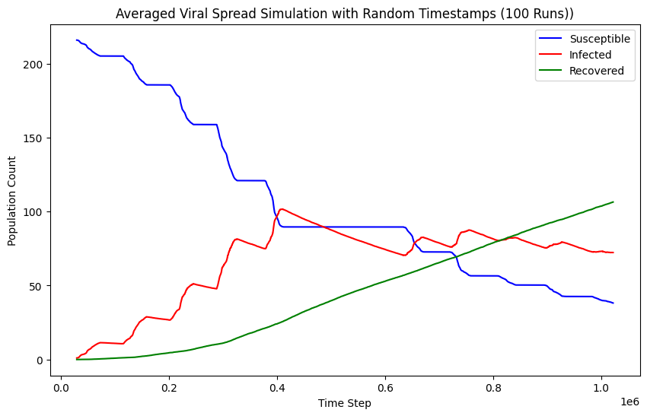
Figure 28: Shuffled Timestamp SIR Graph
Unlike the Control graph, the shuffled timestamp graph has an early peak at the end of the first Friday, leading to a spike in recovered over the weekend and a petered out spread in the following week.
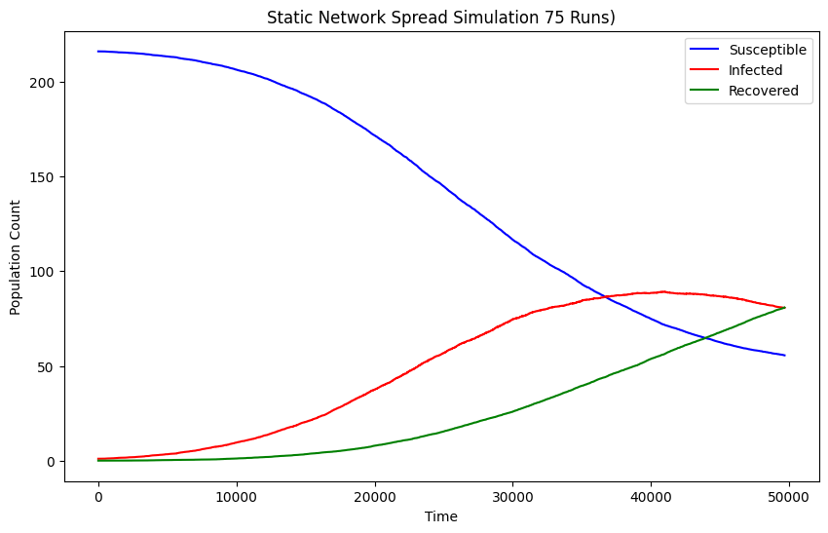
Figure 29: Static Network SIR Graph

APPENDIX E – Research Ethics Checklist

APPENDIX F – Network Metric Explanations

Clustering Co-efficient
Clustering co-efficient is a nodal property that shows the proportion of a node’s neighbours to form triangles. For example, if A is connected to B and C, if B is connected to C, then that would form a triangle. This shows the tendency of a node to form a community between its neighbours. It is given by the following formula, where v is the node in question, e_{v} is the number of edges between the neighbours of v and k_{v} is the number of neighbours of v.

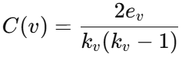
Figure 7: Clustering Coefficient Formula

Transitivity
Transitivity is similar to clustering coefficient in that it counts triangles, but as a network wide metric. It shows the overall probability for the two neighbours of a node to also be connected. A network with high transitivity will have a structure consisting of tightly knit local groups within which a virus would spread quickly. It is calculated by dividing the number of triangles in the network by the number of triplets (3 nodes connected by 2 edges, precursor for a triangle).

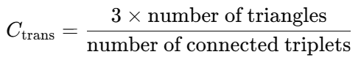
Figure 8: Transitivity Formula

Degree
Degree is simply the number of edges that are connected to a given node. The average degree can be used to show the connectivity of the network and can influence spreading rate, since the more edges there are, the more opportunities there are for infection.

Diameter and Radius
The diameter of a network is the longest shortest path that can be taken between two nodes. The radius is calculated by finding the length of the longest shortest path of each node, and selecting the smallest, just like how the centre of a circle has the shortest maximum distance to the circle’s edge.

These metrics are significant as they show the best (radius, starting from the centre and travelling outwards) and worst (diameter, starting from the edge and travelling all the way across) case spreading paths.

Degree Assortativity
Degree Assortativity is the Pearson correlation coefficient between the degrees of connected node pairs, ranging from -1 to 1. A high positive assortativity shows that nodes with high degree are likely to connect to other nodes of high degree, while a high magnitude negative assortativity shows that high degree nodes are likely to connect to nodes with low degree. An assortativity of 0 shows no correlation between degrees of node pairs.

A high assortativity would show the likelihood of there being an exclusive clique of the highest degree nodes where the virus would spread very fast throughout but not much beyond. A low assortativity would show that high degree nodes would spread the virus to broadly to the more isolated nodes, but not so much to each other.

